Lab 5

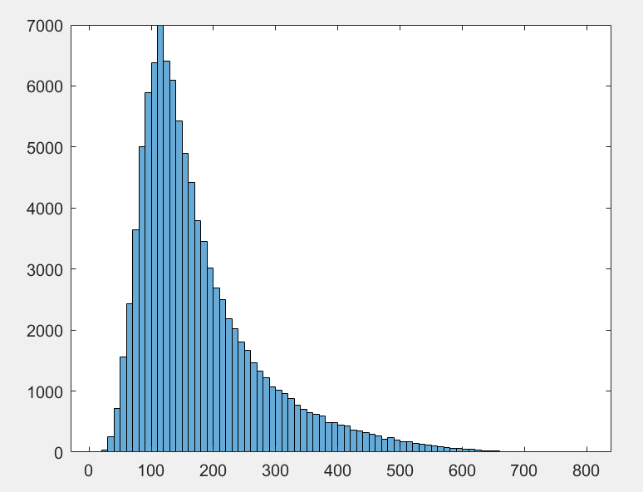

The Atlas detector at CERN confirmed the discovery of a new particle on 4th July 2012 called the Higgs Boson with mass around the 125Gev region. With the data provided with us in this lab we can see that the mass is at 126 ± 0.8Gev. In our given data set we have 14 variables both for the Higgs Boson signal and the QCD background. A detailed picture of the detector is shown below.

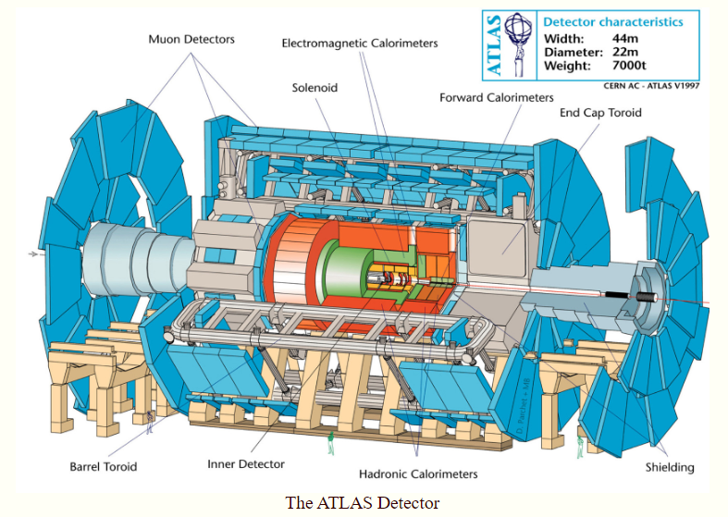

As particles collide inside the detector, they pass through various layers of sensors namely the tracking detectors, Calorimeters and a Muon Spectrometer. All these detectors help one differentiate between a signal of a decaying Higgs Boson and other particles.

***Tracking Detectors***

The combination of different techniques used in the inner tracking system of ATLAS gives very robust pattern recognition and high precision in both φ and z coordinates i.e. variables phi and eta are given through the measurements made inside the tracking device. Silicon is really suited for detection due to their fast response and great spatial distribution: as a charged particle crosses the material it knocks electron from atoms and within the applied electric field these move giving a very small pulse of current lasting a few nanoseconds. This small amount of charge is then amplified by APV25 chips, giving us “hits” when a particle passes, allowing us to reconstruct its path. In addition, the electron identification capabilities of the whole experiment are enhanced by the detection of transition-radiation photons in the xenon-based gas mixture of the straw tubes.

***Calorimeters***

The barrel EM calorimeter is contained in a barrel cryostat, which surrounds the tracking detectors. The solenoid which supplies the 2 T magnetic tracker field is integrated into the vacuum of the barrel cryostat and is placed in front of the EM calorimeter. Two end-cap cryostats house the end-cap EM and hadronic calorimeters, as well as the integrated forward calorimeter. These calorimeters return all the energy related variables namely : pt,mass,ee2,ee3 and d2.

1. pt is the momentum of the particles and is measured in GeV.
2. Mass is a derived quantity from the momentum of a particle from the total energy relation as there’s no potential energy as particles are in pure motion.
3. ee2 and ee3 or the 2 point energy correlation function and 3 point correlation function are based on the energies and pair-wise angles of particles within a jet and sensitive to two and three-prong substructure, respectively.
4. d2 optimizes the ability to separate the N-subjettiness i.e. between different shapes of jets,

***Muon Spectrometer***

It is instrumented with separate trigger and high-precision tracking chambers. Measurements are based on the magnetic deflection of muon tracks in the large superconducting air-core toroid magnets. The toroidal magnet configuration provides a field that is mostly orthogonal to the muon trajectories, while minimizing the degradation of resolution due to multiple scattering. Thus giving us the values for the ratios of the jet shape in form of t1,t2,t3,t23 and t21. This helps differentiate if a given jet resembles two or one subjects. These help us filter data out as these jets are analogous to Feynman diagrams. Thus one can determine whether the particle decay is of a Higgs boson or not. This can be done by find out the rho value of the data. ‘rho’ which is a dimensionless mass scale variable is used to describe the correlation between jet b tagging discriminator, jet mass and jet pt. With events with only rho within range (-6<rho<-2.1) are fully efficient value for Higgs Boson signal with which our data agrees(as shown in code).This verifies the data to be 100% efficient and with the efficiency test of the background one can see the filtering still needs improvement but this can be an optimization technique. As there are 204 True Negatives in the data of 100k and 6696 false negatives in the background.

***Bibliography***

1. “Expected Performance of Boosted Higgs (→ Bb¯) Boson Identification with the ATLAS Detector at √ s = 13 TeV.” *Https://Cds.cern.ch/Record/2042155/Files/ATL-PHYS-PUB-2015-035.Pdf*.
2. “The ATLAS Experiment.” *Http://Www.scholarpedia.org/Article/The_ATLAS_experiment*.